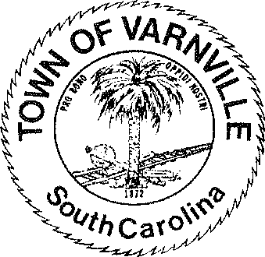
NATHANIEL "Nat" A. SHAFFER COUNCIL:

Mayor
HENRY A. CAMPBELL
Mayor Pro-Tem

www.varnvillesc.org
Ronald Williams Linda Cooler Joseph Williams Faye H Gooding Nicholas Ginn

- Call to Order
  - Invocation

Varnville Town Council Special Meeting Agenda Tuesday, August 26th 2025, 6:00 PM
Town Hall - 95 East Palmetto Avenue

  - Pledge of Allegiance
  - Freedom of Information Act (FOIA) Compliance

- Consent Agenda Items
  - Approval of Agenda

- 1. Executive Session

  - Section 30-4-70 (a) (1) Discussion of employment, appointment, compensation, promotion, demotion, discipline, or release of an employee, a student, or a person regulated by a public body or the appointment of a person to a public body in the Police, Fire and / or Administration departments.
  - Section 30-4-70 (a) (2) Discussion of negotiations incident to proposed contractual arrangements and proposed sale or purchase of property, the receipt of legal advice where the legal advice relates to a pending, threatened, or potential claim or other matters covered by the attorney client privilege, settlement of legal claims, or the position of the public agency in other adversary situations involving the assertion against the agency of a claim.

- The council will act on Executive Session matters if required or warranted

- Adjournment

