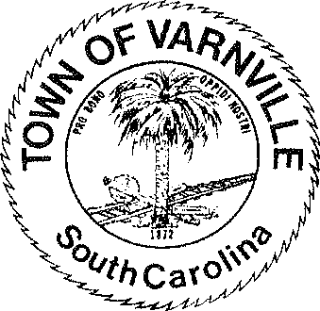
NATHANIEL "Nat" A. SHAFFER COUNCIL:

Mayor
HENRY A. CAMPBELL
Mayor Pro-Tem
Ronald Williams Linda Cooler Joseph Williams Faye H Gooding Nicholas Ginn

www.varnvillesc.org

Varnville Town Council Meeting Agenda Tuesday, September 10th, 2024, 7:00 PM Town Hall - 95 East Palmetto Avenue
- Call to Order
  - Invocation
  - Pledge of Allegiance
  - Freedom of Information Act (FOIA) Compliance

- Consent Agenda Items
  - Approval of agenda
  - Approval of minutes; 08/13/2024 & 09/03/2024 meetings

- Reports of Department Heads, Committees, and guest on the agenda
  - Administration, Police, Fire, LRWS Commissioner
(Announcements that do not require council action will be made here, discussion is limited)
  - Appointment to committees- Council Committees via Mayor and Committees via Council
  - Christopher S. Inglese Deputy Administrator of Community Services, Hampton County
    - An MOU to memorialize the possibility of the school board conveying the Wade Hampton high school property to the county for the purpose of it becoming a county recreation complex.
    - An MOU with MalsPalz to build a new Animal Shelter within town limits of Varnville.Hampton County
  - Celebrating Small Town America Festival-Maggie Knox, Kenny Boyer, Etal
- Old Business
  - (Second Reading) The Town of Varnville Flood Damage Prevention Ordinance
- New Business
  - Discission / Action on Budgetary matters; revenue and expenditures
    - CDBG Loan fund activity
    - ARP fund activity
    - General Obligation Bond and General Revenue Bond activity
  - Discussion / Action on purchase of Forklift / Lull & Basket

- Executive session
  - Section 30-4-70 (a) (1) Discussion of employment, appointment, compensation, promotion, demotion, discipline, or release of an employee, a student, or a person regulated by a public body or the appointment of a person to a public body in the Police and / or Administration departments
- Council will act on Executive Session matters if required or warranted

- Adjournment
The next regular council meeting will be Tuesday October 08, 2024
95 PALMETTO AVENUE EAST • P.O. BOX 308 • VARNVILLE, S.C. 29944-4726
803.943.2979 • Fax: 803.943.4263

