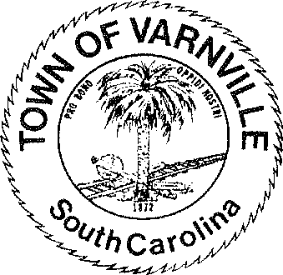
NATHANIEL "Nat" A. SHAFFER COUNCIL:

Mayor
HENRY A. CAMPBELL
Mayor Pro-Tem
Ronald Williams Linda Cooler Joseph Williams Faye H Gooding Nicholas Ginn

www.varnvillesc.org

Varnville Town Council Meeting Agenda Tuesday, March 12, 2024, 7:00 PM Town Hall - 95 East Palmetto Avenue
- Call to Order
  - Invocation
  - Pledge of Allegiance
  - Freedom of Information Act (FOIA) Compliance

- Consent Agenda Items
  - Approval of agenda
  - Approval of minutes 02/13/2024

- Reports of Department Heads, Committees, and guest on the agenda
  - Administration, Police, Fire, LRWS Commissioner
(Announcements that do not require council action will be made here, discussion is limited)

- Public Hearing
  - None
- Old Business
  - Creation of a Non-Profit(s) and / or partnership with Community Foundation of the Lowcountry
  - Second reading, Ordinance #2024-03 Rules regulation and certain prohibitions for door-to-door sales (Peddlers)
  - Ordinance #2024-04 Updated Fee agreement / schedule with SAFEbuilt (Building Dept Services)
  - Ordinance #2024-02 Commercial trash collection dumpsters, bins and similar facility’s buffer and site standards. (Postponed until Public Hearing Scheduled for 04/09/2024)
- Executive Session
  - Section 30-4-70 (a) (2) Discussion of negotiations incident to proposed contractual arrangements and proposed sale or purchase of property, the receipt of legal advice where the legal advice relates to a pending, threatened, or potential claim or other matters covered by the attorney client privilege, settlement of legal claims, or the position of the public agency in other adversary situations involving the assertion against the agency of a claim

- New Business
  - Executive session matters will be acted upon here if warranted or required

- Adjournment
  - The next regular council meeting will be Tuesday April 09, 2024

