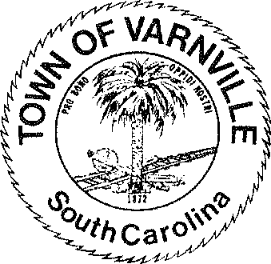
NATHANIEL "Nat" A. SHAFFER COUNCIL:

Mayor
HENRY A. CAMPBELL
Mayor Pro-Tem
Ronald Williams Linda Cooler Joseph Williams Faye H Gooding Nicholas Ginn

www.varnvillesc.org

Varnville Town Council Meeting Agenda Tuesday, January 23, 2024, 7:00 PM Town Hall - 95 East Palmetto Avenue
- Call to Order
  - Invocation
  - Pledge of Allegiance
  - Freedom of Information Act (FOIA) Compliance

- Consent Agenda Items
  - Approval of agenda
  - Approval of minutes 11/27/2023

- Reports of Department Heads, Committees, and guest on the agenda
  - Administration, Police, Fire, LRWS Commissioner
(Announcements that do not require council action will be made here, discussion is limited)

- Public Hearing
  - 964 Carolina Ave. -Unsafe Conditions of Exterior Structure-Condemnation 42 Bennett St.- Unsafe Conditions of Exterior Structure-Condemnation
- Old Business
5.1.

- Executive Session
  - Section 30-4-70 (a) (1) Discussion of employment, appointment, compensation, promotion, demotion, discipline, or release of an employee, a student, or a person regulated by a public body or the appointment of a person to a public body in the Police, Fire and / or Administration departments.

- New Business
  - Ordinance #2024-01 Amending the business license ordinance of the Town of Varnville to update the class schedule as required by act 176 of 2020
  - Election of Mayor Pro Tempore
  - Appointment of Fire Chief
  - Update and review of dilapidated buildings and abatement thereof
  - Ordinance #2024-02 Commercial trash collection dumpsters, bins and similar facility’s buffer and site standards.
  - American Rescue Plan (ARP) money review

- The next regular council meeting will be Tuesday February 13, 2024

- Adjournment
95 PALMETTO AVENUE EAST • P.O. BOX 308 • VARNVILLE, S.C. 29944-4726
803.943.2979 • Fax: 803.943.4263

