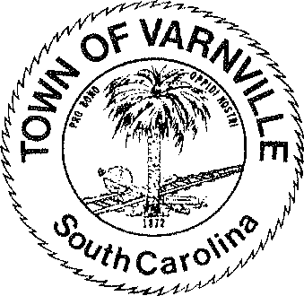NATHANIEL "Nat" A. SHAFFER COUNCIL:

Mayor

HENRY A. CAMPBELL

Mayor Pro-Tem

[www.varnvillesc.org](http://www.varnvillesc.org/)

Ronald Williams Linda Cooler Joseph Williams Faye H Gooding Nicholas Ginn

Varnville Town Council Meeting Agenda Tuesday, January 09, 2024, 7:00 PM Town Hall - 95 East Palmetto Avenue

1. Call to Order
   1. Invocation
   2. Pledge of Allegiance
   3. Freedom of Information Act (FOIA) Compliance
2. Consent Agenda Items
   1. Approval of agenda
   2. Approval of minutes 11/27/2023
3. Reports of Department Heads, Committees, and guest on the agenda
   1. Administration, Police, Fire, LRWS Commissioner

(Announcements that do not require council action will be made here, discussion is limited)

1. Public Hearing
   1. 964 Carolina Ave. -Unsafe Conditions of Exterior Structure-Condemnation 42 Bennett St.- Unsafe Conditions of Exterior Structure-Condemnation
2. Old Business

5.1.

1. New Business
   1. Ordinance #2024-01 Amending the business license ordinance of the Town of Varnville to update the class schedule as required by act 176 of 2020
   2. Election of Mayor Pro Tempore
   3. Appointment of Fire Chief
   4. Update and review of dilapidated buildings and abatement thereof
2. The next regular council meeting will be Tuesday February 13, 2024
3. Adjournment

*95 PALMETTO AVENUE EAST • P.O. BOX 308 • VARNVILLE, S.C. 29944-4726*

*803.943.2979 • Fax: 803.943.4263*

