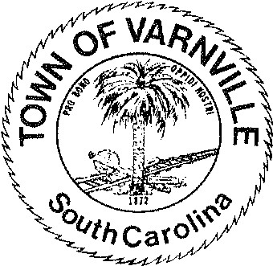
NATHANIEL "Nat" A. SHAFFER COUNCIL: Mayor Ronald Williams
Linda Cooler
HENRY A. CAMPBELL Joseph Williams
Mayor Pro-Tem Faye H Gooding
Nicholas Ginn

www.varnvillesc.org

Varnville Town Council Meeting Agenda Tuesday, February 13, 2024, 7:00 PM Town Hall - 95 East Palmetto Avenue

- Call to Order
  - Invocation
  - Pledge of Allegiance
  - Freedom of Information Act (FOIA) Compliance

- Consent Agenda Items
  - Approval of agenda
  - Approval of minutes 01/23/2024

- Reports of Department Heads, Committees, and guest on the agenda
  - Administration, Police, Fire, LRWS Commissioner
(Announcements that do not require council action will be made here, discussion is limited)

- Public Hearing
  - Ordinance #2024-02 Commercial trash collection dumpsters, bins and similar facility’s buffer and site standards. (Hearing is postponed to March 12, 2024

- Old Business
  - Second Reading, Ordinance #2024-01 Amending the business license ordinance of the Town of
Varnville to update the class schedule as required by act 176 of 2020
  - Second Reading, Ordinance #2024-02 Commercial trash collection dumpsters, bins and similar facility’s buffer and site standards

- Executive Session
  - Section 30-4-70 (a) (1) Discussion of employment, appointment, compensation, promotion, demotion, discipline, or release of an employee, a student, or a person regulated by a public body or the appointment of a person to a public body in the Police, Fire and / or Administration departments.
  - (5) Discussion of matters relating to the proposed location, expansion, or the provision of services encouraging location or expansion of industries or other businesses in the area served by the public body

- New Business
  - Executive session matters will be acted upon here if warranted or required.
  - Appointment of Fire Chief
  - Discussion and / or appointment(s) to the planning commission
  - Creation of a Non-Profit(s) and / or partnership with Community Foundation of the Lowcountry
  - Ordinance #2024-04 Updated Fee agreement / schedule with SAFEbuilt (Building Dept Services)
  - Ordinance #2024-03 Rules regulation and certain prohibitions for door-to-door sales (Peddlers) 7.8. Discussion of Branding and topics related to the Branding of the Town of Varnville
- Adjournment
95 PALMETTO AVENUE EAST • P.O. BOX 308 • VARNVILLE, S.C. 29944-4726
803.943.2979 • Fax: 803.943.4263

